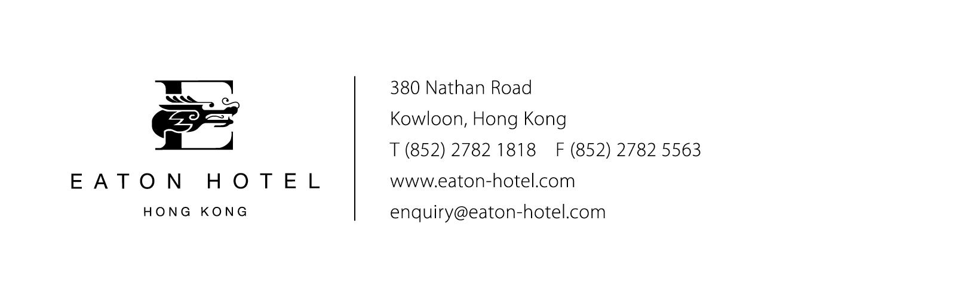
Bowie Ho – Assistant Director Of Sales
Fax no. (852) 2385 8132
bowieho@eaton-hotel.com
The HK Polytechnic University - EDOC 2006 (16 – 20 October)

Hotel Reservation Form for The 10th IEEE Int’l EDOC Conference

New Booking Amendment Cancellation

Arrival Details

Arrival Date: ________________ (Flight) ________________

Departure Date: __________________ (Flight) ________________(Total: ______ room night)

Guest Name Contact

_______________________________ _ Fax: e-mail:

Number of Room Required : ____________________

Daily Rate
Room Only Room + 1 Buffet Breakfast Room + 2 Buffet Breakfast
Regular HK$1100 HK$1200 HK$1300

Superior HK$1200 HK$1300 HK$1400

*Room Rates are INCLUSIVE of 10% Service Charge and 3% Government Tax per room per night.

Special Request

_____________________________________________________________________________________

All reservations MUST BE made before 25 September 2006 and guaranteed by Credit Card or otherwise will be subject to space availability.

Type of credit card : ____No. __________________ -_

Name of Cardholder : _______________________ Expiry Date :

The hotel should be advised of cancellation no later than 07 days prior to guests’ arrival; otherwise, a penalty of one night room rental will be made.

Non-guaranteed bookings will be released 07 days prior to the arrival date.

Mode of payment
Guest Own Account Credit Card (as above)
Deposit to bank account no. “004-016-083628-001”of ”The Hong Kong & Shanghai Banking Corp. Ltd”

(Kindly please send back the bank advice to our fax number for identification)

Airport Transportation Service

Hotel Limousine service @HK$440 per trip
Hotel Link (deluxe coach) @HK$120 for Arrival @HK$120 for Departure
Not required
- Hotel Link are based on a fixed time schedule
- Arrangement of airport Transfers will be based on the above flight information provided
- To meet the transfer pick up service, use EXIT A or B after customs clearance and proceed towards “B04 Langham Hotels Int’l ” counter.

Confirmed & Accepted by (for hotel use)

Name:
Eaton Hotel Hong Kong
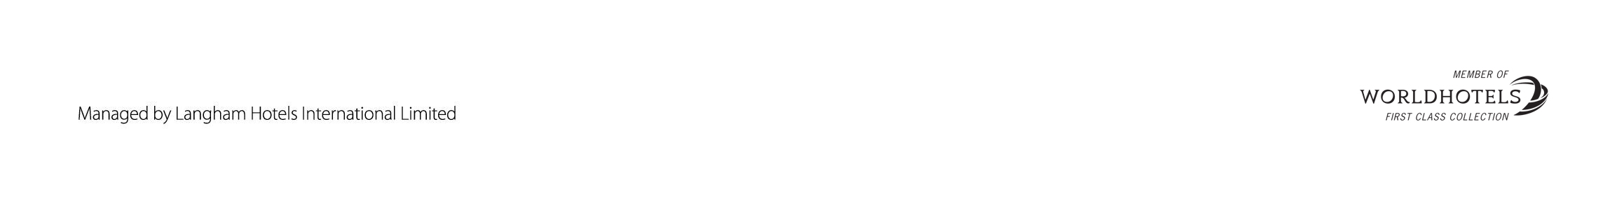Signature: Date: __

