DELIVERABLE D2.2 – Hong Kong Conference Report

1° Reporting Period



RISE PROJECT

Project funded by the European Commission-FP7

Grant Agreement n°: 230389

Coordination Action (CA)

Start date of the project: 1 March 2009

Duration: 36 months

|  |  |
| --- | --- |
| Deliverable: | D2.2 |
| Title: | Hong Kong Conference Report |
| Due date: | 31.03.2010 |
| Actual submission date: | 20.05.2010 |
| Lead contractor for this deliverable: | Hong Kong Polytechnic University |
| Contact: | [Ajay.Kumar@inet.polyu.edu.hk](mailto:Ajay.Kumar@inet.polyu.edu.hk) |
| Dissemination Level: | PU |

www.riseproject.eu

Table of Contents

1. Introduction3
2. Background of Conference3
3. Preparation for the Conference4
   1. **Conference Venue and Logistics**
   2. **Invitation for Speakers**
4. The Third International Conference5
5. Call for Papers14
6. Abstracts and Biographies15
7. Media Coverage28
8. Conference Organization and Proceedings Organization31
9. List of Participants34
10. Speakers Presentations38
11. Appendix A: Conference Brochure106
12. Appendix B: Conference Proceedings136
13. Introduction

Human identification using their physiological and behavioural characteristics, *i.e*. biometrics, is increasingly mapped into range of new civilian and commercial applications. The past decade has seen a rapid growth in the demand for biometrics and data security technologies for a wide range of applications in education, law enforcement, immigration, healthcare, online security and financial services. The biometrics based technologies have opened new frontiers for medical diagnosis and information security. However recent research and deployment reports have shown that with negligible-to-modest effort, many leading biometric technologies are susceptible to attacks in which fake fingerprint tapes, static facial images and static iris stamps/images have been successfully employed as biometric samples. These fraudulent samples are processed by the biometric system to generate templates and to verify enrolled individuals. There has been a newfound urgency after September 11 attacks to develop cutting-edge security technologies. However, the performance of currently available biometrics technologies is yet to mature for its broad deployment in real environments. Performance estimation is a key issue in the comparison and evaluation of the biometric and biometric system in large scale secure access technology*.* The challenge lies in devising the effective performance indices and evolving their interdependence to convey security, accuracy, privacy and such other performance measures currently debated in the literature. In addition, the increasing usage of biometrics technologies have raised more concerns on the ethics, privacy and policy implications of biometrics.

The large scale deployment of biometrics technologies has highlighted several challenges in the management of human identities. The large scale deployment and development of next generation biometrics system must address the increasing concerns on the ethics, privacy and policy implications. The novel biometrics sensing, signal/image representation, storage, retrieval, transmission, encryption, matching and decision making techniques have to be developed to address the ethical, legal, cultural and social concerns in the management of human identities. The challenges posed in the deployment and development of promising biometric technologies can be largely observed from *engineering perspective*, and from *social perspective*. Several research presentations have shown that when social and ethical factors are internalized into the technical design and decision making, the solution tends to be more effective, compatible and cost effective.

1. Background of Conference

The Third International Conference on Ethics and Policy of Biometrics and International Data Sharing, also referred to as third RISE (Rising Pan European and International Awareness of Biometrics and Security Ethics) meeting, is essentially a key milestone in the ongoing dialogue process within the scope of RISE project. This conference has been planned and fully scheduled in the European Commission supported RISE project no. 230389 funded under FP7, SP-4 Capacities.

The increasing deployment of cutting edge security technologies has invited renewed concerns on the ethics, privacy and policy implications on the usage of these technologies. However, these concerns are not new but have also been raised and discussed earlier in the previous two conferences. The first of this conference was organized by European Commission in 2005 in Brussels and second one in 2006 in Washington DC, by the US Department of Homeland Security and the US Visit Program. The third international conference has been particularly organized in Asia by the RISE consortium to more actively involve the regional stakeholders in the dialogue process. The host city of Hong Kong in China was judiciously selected to avail the better connectivity and visa free entry for the likely participants from most of the countries. The key idea of the organizers has been to seek more active participation from the Chinese and Indian law enforcement, border control, privacy protection and the regulatory bodies in the dialogue process and bring awareness on the implications and challenges in the deployment of the biometrics technologies.

1. Preparation for the Conference

The preparation for the conference started soon after the conclusion of the kick off meeting which was held in Rome on 12-13 March 2009. The initial task has been to come up with *call for papers*, develop and install a *conference website*, install a reliable *conference paper submission* and *review submission system*, select and book the conference venue, accommodation arrangement and booking for the conference participants. Some of these tasks like development of conference website, circulation for call for paper, booking the conference venue, *etc*. have to be started much in advance, even before the arrival of the initial funding from the RISE project. Therefore the organizers have to manage the resources from elsewhere and anticipate the cost in advance. The mass mailing of the call of paper started from [iceb@comp.polyu.edu.hk](mailto:iceb@comp.polyu.edu.hk) in May 2009 itself and the initial deadline for the paper submission was set as 1st September, 2009. Online paper submission link was made available at <http://iceb.comp.polyu.edu.hk/myreview/SubmitAbstract.php> and the deadline for the paper submission was extended to seek more quality papers. The task of attracting potential authors to submit papers on the interdisciplinary topics in biometrics, *i.e.*, the policy implications and the potential concerns with the biometrics and data security technologies, was challenging. The call for paper and participation was also posted on public notice boards in major international conferences, like BTAS 2009 held in Washington, whenever the program committee members had opportunity to visit such conferences. The conference website <http://www.comp.polyu.edu.hk/conference/iceb> was regularly updated with the *links* and news from the most recent incidents depicting the challenges associated with the usage of biometrics and data protection technologies. Several social action groups, established research and development institutions on the bioethics, law enforcements, data privacy and protection regulatory bodies, system integrators, users and developers of biometrics technologies were located from all over the world and encouraged to submit the papers and participate in the conference. The call of papers for this conference is available on page 14 in this report. As can be noticed from the attached document, the call of papers clearly outlined the extended range of topics that would be of potential interest in the multidisciplinary domain of this conference.

* 1. Conference Venue and Logistics

The prime consideration in selecting the conference hall and location was the ease of access, quality of amenities, convenience and importantly the cost. The venue was therefore selected as the Senate Room of The Hong Kong Polytechnic University which is located within the campus. The hiring of the supporting staff for the short term duration to for the conference activities was highly challenging. Our two regular advertisements to seek the employment for the support staff were not attractive. However, we managed to employ several part time student helpers and some part time research assistants (whose names kept changing after few months!). The conference organizers also supported and supervised the accommodation arrangements for the speakers and the participants. We contacted three different hotels, all located within the walking distance from the conference venue, to seek the discounted accommodation for the participants. The accommodation rates has to be negotiated much in advance as the January is the high season month in Hong Kong that typically experiences highest tourist traffic flow. The accommodation arrangement for all the key note speakers was supervised and supported by the local staff in our university.

* 1. Invitation for Speakers

The ‘India Preparatory Meeting on Biometrics and Data Protection' that was held in New Delhi on September 24-25, 2009 provided another venue for the discussion on the agenda for the third international conference and the selection of speakers. Each of the submitted paper was reviewed by at least two reviewers and large number of papers submitted were highly technical in nature and therefore rejected since there are already several other venues for submitting/presenting such papers. The review results of the papers submitted for the conference was prepared and the authors were notified for the decision on their papers along with the comments from the reviewers. A preliminary list of key note speakers to be approached for their possible talk and participation during the Hong Kong conference was prepared during the India preparatory meeting. This list was continuously revised and updated largely based on the outcome of the pursued invitations, feedback from the conference chairs. We selected 25 speakers for the conference and received their final confirmation for the talk. All of the nonlocal invited keynote speakers were supported for their travel and accommodation during the conference visit.

1. The Third International Conference

The Third International Conference on Ethics and Policy of Biometrics and International Data Sharing was held in Hong Kong on January 4-5, 2010. This conference was the first major international event from the RISE project in the Asia Pacific region to promote the dialogue among the key stakeholders. The conference witnessed the participation of over 150 registered participants. The conference program invited world-wide attention, with the attendances from 19 countries and regions including – Belgium, China, France, Hong Kong, India, Italy, Israel, Japan, New Zealand, Belgium, Slovenia, Switzerland, Estonia, Taiwan, Malaysia, Australia, United Kingdom, United States. The conference program gave broad coverage to the social, cultural, ethical, legal and technical challenges in the deployment/development of biometrics applications and technologies; and government interests were also represented. Among those departments that participated were the law enforcement agencies from USA, Israel and representatives from the Hong Kong Police Force, Hong Kong Immigration Office, Office of Hong Kong Privacy Commissioner, and public media, including Radio Television Hong Kong (RTHK), Television Broadcast Limited (TVB), Ming Pao, and The Standard. The conference program witnessed 25 oral presentations, and promoting interactions and discussion among the conference participants that stimulated a wealth of new ideas. The breadth of international and social representation was one of the key advantages of lively discussions that prompted immediate feedback/comments on relevant issues.

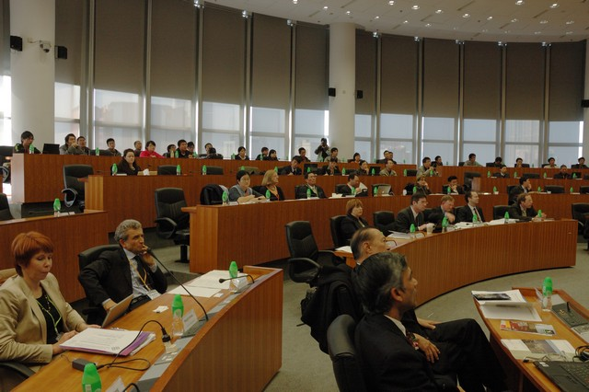The conference opened after a warm welcome opening address by Prof. David Zhang from The Hong Kong Polytechnic University, and three opening speeches by Dr. Hon Samson Tam, Legislative Councillor; Prof. Emilio Mordini from Centre for Science, Society and Citizenship, Italy; and Prof. Alex Wai from The Hong Kong Polytechnic University. Prof David Zhang highlighted that this was not a conventional biometrics conference and outlined on the raising concerns and issues with the deployment of biometrics and data security technologies. He motivated the conference delegates to develop some consensus on the policy issues, extensively review the current practices, evaluate the concerns and cost benefits from evolving technologies and outline the strategies to meet the privacy and socio-technological challenges. Dr. Hon Samson Tam noted that the biometrics characteristics are exploited not only for the automated personal identification to ensure security but also for the medical diagnosis. He congratulated the Biometrics Research Centre for successfully cultivating technological innovations from highly motivated researchers and actively participating in this dialogue to address the ethical and social concerns on the deployment of the new technologies. Prof. Emilio Mordini gave the historical perspective on the conference and provided an overview on the open issues from the previous two conferences organized in Brussels and

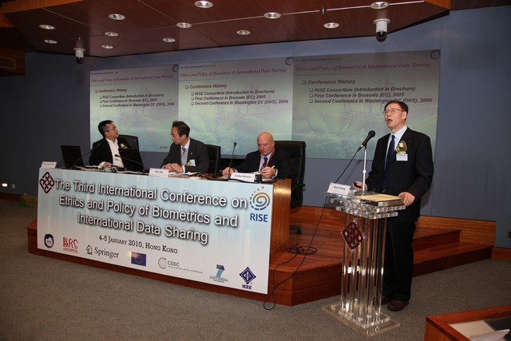 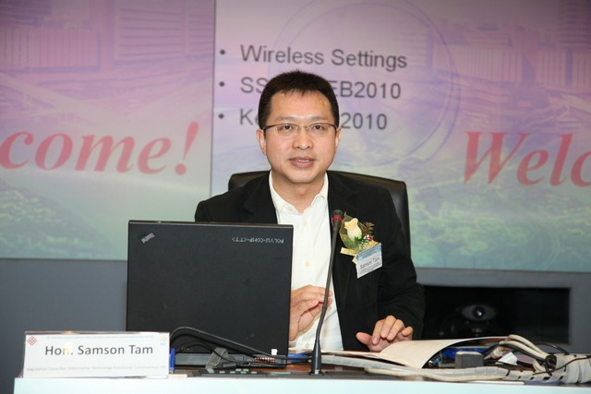

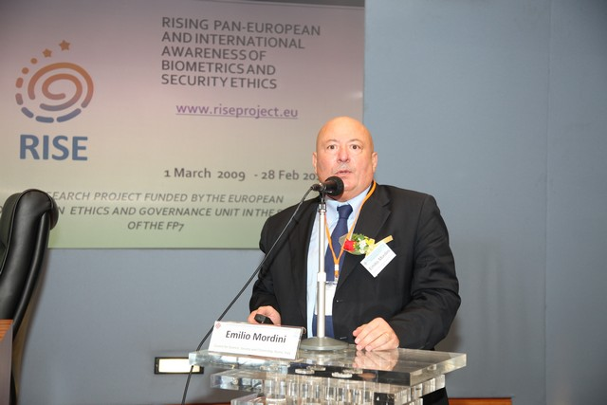 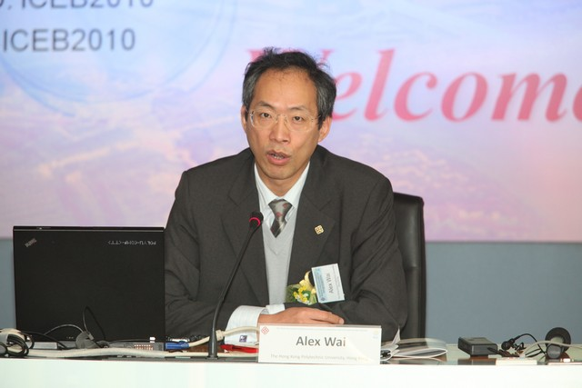

Upper left: Prof. David Zhang, from The Hong Kong Polytechnic University, delivering the welcome address; Upper right: Dr. Hon. Samson Tam, JP, Legislative Councilor Hong Kong, speaking during the welcome session; Lower left: Prof. Emilio Mordini, RISE Project Coordinator, delivering welcome speech and introducing the RISE, BITE and HIDE projects; Lower right: Prof. Alex Wai, Dean of Engineering, The Hong Kong Polytechnic University, delivers the opening address.

Washington DC by the European Commission, US DHS and the US Visit Program respectively. He detailed on the organization of European Commission supported RISE project, the conference agenda, motivated the policy regulators and the participants to coming up with some consensus and policy recommendations on the ethical, medical, legal, social, cultural and political concerns in the deployment of biometrics and data security technologies. The welcome session was concluded by Prof. Alex Wai, who drew the attention of participants towards the successful usage of fingerprint based Hong Kong ID cards in Hong Kong which provides a model for the effective deployment of biometrics technologies for the benefits of citizens in e-governance and in high-speed border crossings. He noted that the utilities offered by Hong Kong identity cards seems to apparently outweigh the potential privacy concerns and the Hong Kong residents do not seem overly concerned with the privacy issues. He however necessitated international dialogue on privacy concerns and potential threats on the biometrics and data security technologies.

Mr. Roderick Woo, Privacy Commissioner for Personal Data, Hong Kong, addressed the first opening lecture on the challenges posed by the biometric technologies for the privacy protection and suggested tighter supervision of such sensitive data. “There has been a sharp rise in complaints concerning the collection of biometric data. Most concern the collection of employees' fingerprints by employers for attendance records,” he said. He proposed to classify the biometric data as sensitive personal data and said “The reconstruction of a fingerprint from the minutiae template with striking resemblance is not uncommon and there is a positive match in more than 90 percent of cases for most minutiae matchers.” Mr. Woo noted that healthy society should embrace different and sometimes conflicting interests. Therefore he called up on the users of biometrics data to offer less privacy intrusive alternatives and measures to lessen the adverse privacy impact.

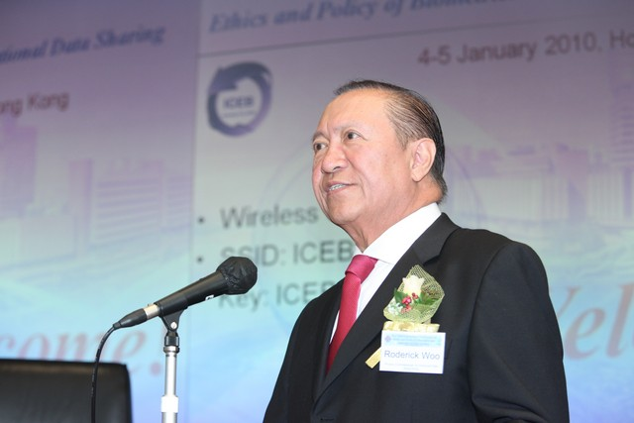 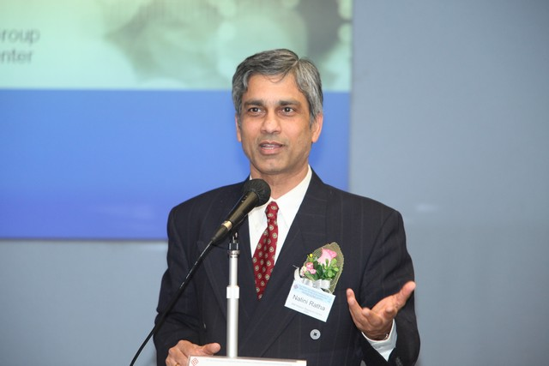

Left: Mr. Roderick Woo, Privacy Commissioner for Personal Data, Hong Kong, delivering the opening keynote address on *Challenges posed by Biometric Technology on Data Privacy Protection in Hong Kong and the Way Forward*; Right: Dr. Nalini Ratha, from IBM J. Watson Research Centre New York, speaking on *Privacy Protection in High Security Biometrics Applications*.

The second keynote speaker Dr. Nalini Ratha, from IBM J. Watson Research Centre, deliberated on the technological advances in the privacy and biometrics data protection technologies. He illustrated the concepts behind the cancellable biometrics and emphasized this as one of the most promising solutions to jointly ensure high security and privacy for the sensitive biometrics data. His speech defended on the promises from evolving biometrics technologies that can offer extremely higher degree of privacy. In this context he detailed on the technical strength of cancellable biometrics developed to protect the biometrics data and ensure privacy. In this context, Dr. Ratha cautioned on the vulnerabilities of typical biometrics system to sophisticated cyber attacks and outlined range of open issues yet to be addressed by the researchers.

 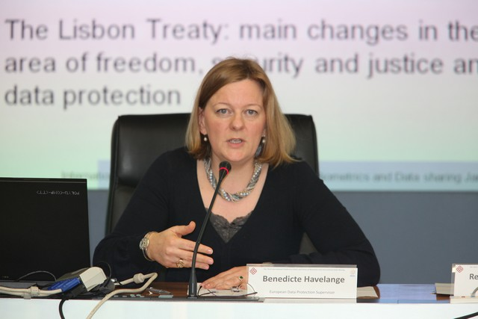

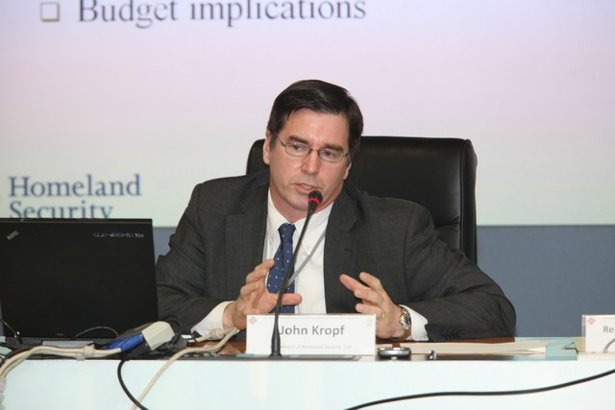

Top Left: Nataša Pirc Musar, Information Commissioner of the Republic of Slovenia, presenting her paper on *The Dangers of Electronic Traces: Data Protection Challenges Presented by New Technologies*; Top Right: Benedicte Havelange, European Data Protection Supervisor, speaking on *Data Protection in Post Lisbon EU*; Left: John Kropf, Deputy Chief Privacy Officer, Department of Homeland Security, delivering the speech on *The Crossroads of Privacy and Biometrics*.

The next session, *i.e*. session A, started with a lively talk from Ms. Nataša Pirc Musar, Information Commissioner of the Republic of Slovenia. She started her speech by stating that strong tools were needed for ensuring safety in modern digital technologies and discussed on range of issues concerning legal and technological aspects in the protection of personal data. Ms. Nataša Pirc Musar further extended the discussion on the privacy while using the internet and concluded that personal privacy can be violated while using popular commercial services like electronic road toll system, CCTV, GPS, *etc*. Ms. Benedicte Havelange, European Data Protection Supervisor continued the discussion as next speaker and highlighted on current data protection practices in Europe and the main changes of the Lisbon Treaty. The second speaker in this session Mr. John Kropf, from the US Department of Homeland Security (DHS), outlined the critical needs for biometrics technologies in the government departments and cited live examples to illustrate the seriousness with which DHS takes privacy. He also gave an example on US-VISIT to illustrate US privacy framework and noted that the existing privacy oversight and accountability in this framework has been recognized internationally. The third speaker of this session, Prof Stan Li, could not make it for this conference due to snow storm related cancellation of all flights from in Beijing. However, the session chair Dr. René von Schomberg used this opportunity to extend the general debate before the scheduled lunch break.

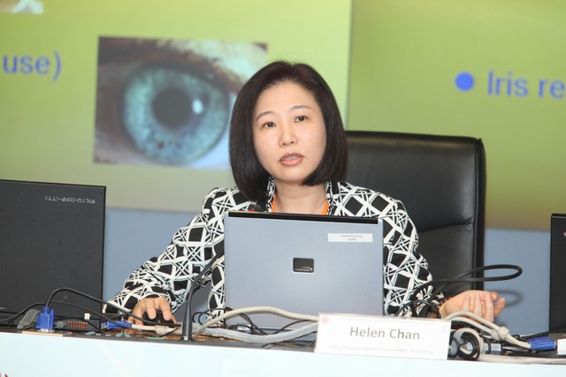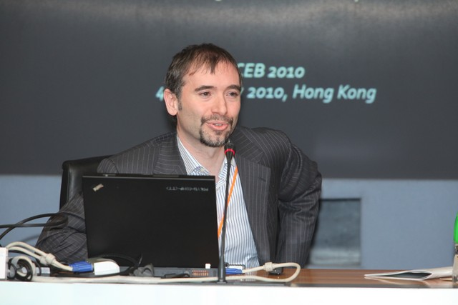 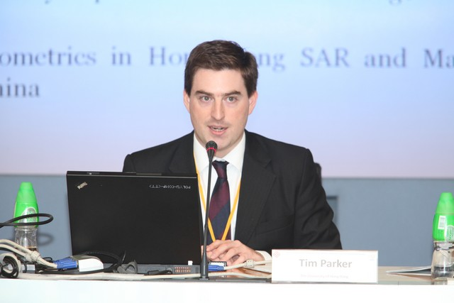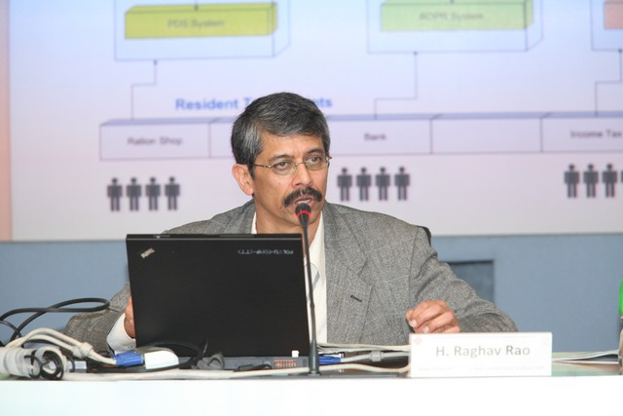   
Upper left: Dr. Helen Chan, from Hong Kong Immigration Department, speaking on *Deployment of Biometrics Systems and Challenges*; Upper right: Dr. Alessandro Acquisti, from Carnegie Mellon University, delivering keynote talk on *Of Frogs and Herds: Behavioral Economics, Malleable Privacy Valuations, and Context-dependent Willingness to Divulge Personal Information*; Lower left: Tim Parker, from The University of Hong Kong, speaks on *Are We Protected? The Adequacy of Existing Legal Frameworks for Protecting Privacy in the Biometric Age*; Lower right: Prof. H. Raghav Rao, from State University of New York, University at Buffalo, presenting his paper on *The Unique Identification Number Project: Challenges and Recommendations.*

The post lunch session, *i.e.* Session B, was firstly addresses by Dr. Helen Chan from the Hong Kong Immigration Department. Her presentation was largely focused on the challenges with the usage of biometrics technologies in the Hong Kong Immigration department. She showed examples of how the DNA, fingerprints, iris, and face traits are effectively exploited to improve the services delivered to the public as well as enhance the security of the identity cards and the travel documents. Prof. Alessandro Acquisti from Carnegie Mellon University gave next presentation that on behavioural economics and privacy related to revelation of personal data. He illustrated the results from a recent a study performed at Carnegie Mellon University which suggested that methods of *soft paternalism* and *nudging privacy* may be the best for increasing individual and societal welfare related to privacy concerns. His study pointed out that the privacy valuations measured by willingness to trade-off personal information for monetary rewards and concerns about privacy measured by divulgence of private information are highly sensitive to contextual factors. Mr. Tim Parker from The University of Hong Kong gave his address which analysed biometrics and privacy protection framework from the legal aspects in Hong Kong and also in the (mainland) People’s Republic of China. Prof. H. Raghav Rao from University at Buffalo, State University of New York, presented his paper on the Unique Identification Number project (UID) recently launched in India. He discussed on some key challenges and made several recommendations for this project to increase the public awareness on the UID program, facilitate faster enrolment and handling, and amend the legal framework for its implementation.

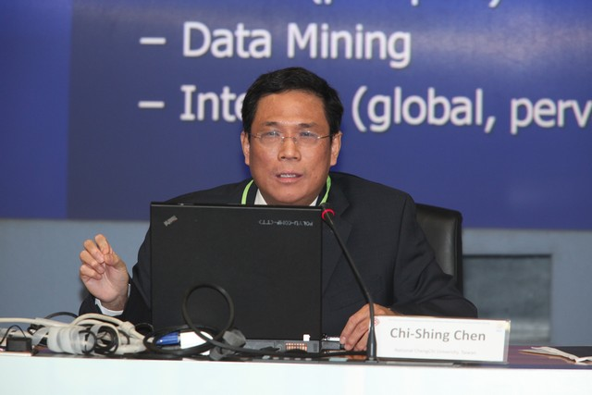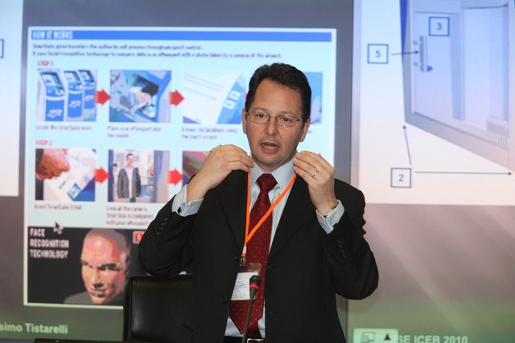 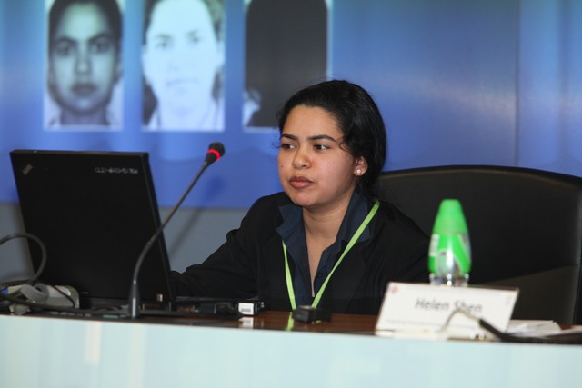

Top Left: Prof. Massimo Tistarelli, from Università di Sassari, delivering his keynote talk on *Human Face Analysis: from Identity to Emotion and Intention Recognition*; Top Right: Dr. Richa Singh, from IIIT Delhi, speaking on *Face Recognition and Plastic Surgery: Social, Ethical and Engineering Challenges*;Left: Prof. Chi-Shing Chen, from National ChengChi University, Taiwan, delivers his talk on *Biometrics Governance: H1N1 as a Case Study*.

The invited talk and paper presentations in Session C were focused on privacy and socio-technological challenges in the biometrics based human identification. Prof. Massimo Tistarelli from the Università di Sassari, Italy, presented a technical analysis on the current and future face recognition technologies and compared them with the conventional human perception capabilities. He expressed concerns on the developing technologies which can be highly privacy invasive and cited recent examples from the facial expression analysis research which is intended to covertly recognize human emotions and intentions. Dr. Richa Singh from IIIT Delhi spoke on the ethical, social and engineering challenges of face recognition while encountering human faces with plastic surgery. Prof. Chi-Shing Chen from National ChengChi University, Taiwan, discussed on the governance with biometrics using the recent challenges involved in the usage of biometrics during H1N1 outbreak.

The theme of session D was on ethical values for the e-Society. Mr. Stephen Mak, Deputy Government Chief Information Officer, Hong Kong, firstly on information, security and privacy. He pointed out that with the emerging business models in the information and communication technology industry like “cloud computing” and “anything as a service” that offer users with easiness and flexibility in more dynamic ways, it is necessary to ensure the security, privacy and ethical issues in many more combinations that would have been required in the past. He also stated that prudent and proper use of biometrics is necessary on technological innovation, security and respect for privacy. Prof. Margit Sutrop, from University of Tartu, delivered her invited talk on ethical issues in governing biometrics. She pointed out that in order to maintain public trust, it is important to let the public have some basic understanding of the biometrics technologies.

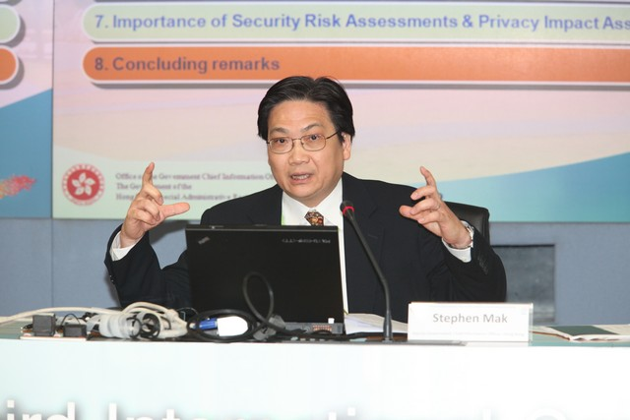 

Left: Mr. Stephen Mak, Deputy Government Chief Information Officer, Hong Kong, speaking on *Information, Security and Privac*y; Right: Prof. Margit Sutrop, from University of Tartu, Estonia, delivers her keynote address on *Ethical Issues in Governing Biometric Technologies – How to Maintain Public Trust?*

The first keynote speech on the second day of conference was delivered by Prof. Xiaomei Zhai, Director Centre for Bioethics, Chinese Academy of Medical Sciences, Beijing. The ethical concerns outlined by Prof. Xiaomei Zhai included privacy, stigmatization, discrimination, the loss of identity, and some relevant decisions that concerns public welfare. She reported several incidents and public concerns on ethics and also suggested several alternatives to achieve good governance. Mr. Blair Stewart, Assistant Commissioner Office of the Privacy Commissioner, New Zealand, gave the next presentation titled “The International Standards on the Protection of Personal Data and Privacy”. In his speech, Mr. Blair made a major digression to explain the promising, but incomplete, attempt to synthesise the sensitive categories approach of the European instruments and the risk-assessment approach of the APEC framework. In doing so he explicitly picked upon on the Hong Kong Commissioner’s suggestion that biometric data be declared ‘sensitive’. He further commended that a special note being made of the Madrid Declaration endorsement of PIA (Privacy Impact Assessment) and other proactive measures from this conference.

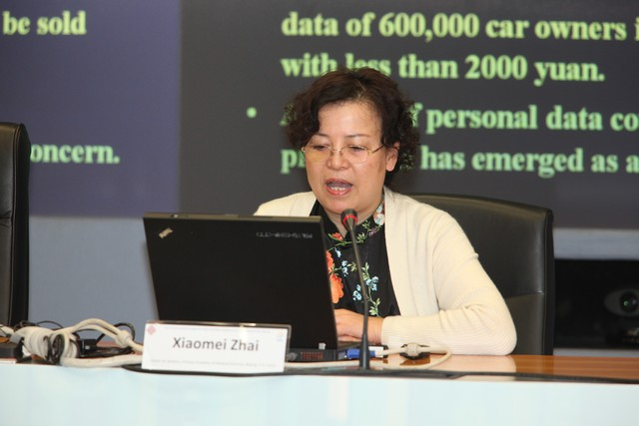 

Upper left: Prof. Xiaomei Zhai, Center for Bioethics, Chinese Academy of Medical Sciences, presents “The Status Quo and Ethical Governance in Biometric in Mainland China”; Upper right: Mr. Blair Stewart, Office of the Privacy Commissioner, New Zealand, talks regarding international standards on protection of personal data and privacy.

The post lunch session E was devoted for invited speeches and paper presentations on the applications of biometrics for security and forensics. Mr. Wing-On Chan, Francis, from Hong Kong Police Force, used the example of *Facebook* and the famous *Tracy Turkish Brooks* case, to effectively argue that the personal information sent out every second while using internet and just replacing password control with biometrics 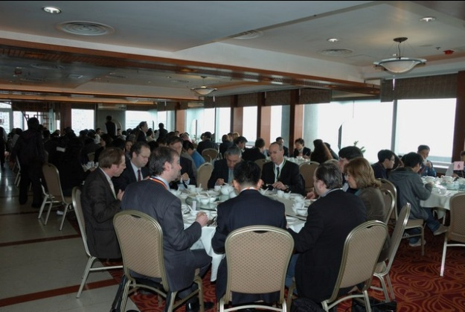authentication would not help. He expressed concerns on the vulnerability of biometric information and how a careless user who pays little attention to protect his password can also leave his biometric profile unprotected. Ms. Kim Legg from INTERPOL delivered next invited talk on international fingerprint and DNA exchange using INTERPOL. She reminded that the criminals do not respect borders and therefore the fingerprint and DNA information should be actively shared among countries. She cited several examples to illustrate successful usage of such facility at INTERPOL which resulted in successful conviction of criminals for the crimes committed in different countries. Dr. Elazar Zadok, Former Director, Identification and Forensic Science Division, Israel, presented his paper on the legislative and ethical questions regarding forensic ‘biometric’ databases. He pointed out that although in forensic the usage of these databases is very effective, they pose a lot of legislative and ethical concerns at the same time. He also argued that a DNA database generates more concerns since it contains sensitive genetic information regarding its owner, but this information may not necessarily be needed for the identification.

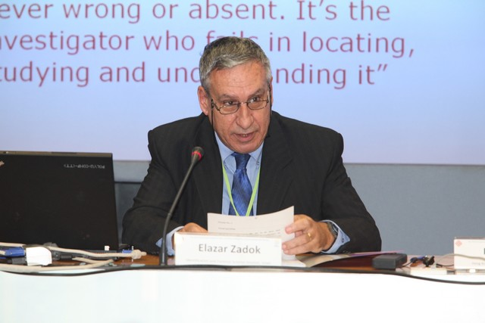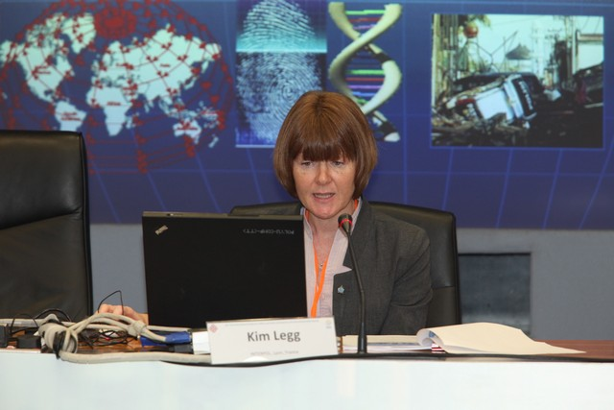

Top left: Wing-On Chan, Francis, from Hong Kong Police Force, speaking on *Biometrics*: *The Hope or Gloom to Crime and Identity?*; Top Right: Kim Legg, from INTERPOL, gives her speech on *international fingerprint and DNA data sharing*; Left: Dr. Elazar Zadok, former director of Identification and Forensic Science Division, Israel delivering his keynote lecture on *legal and ethical issues regarding forensic biometrics databases*.

The session F witnessed four invited talks on relevant topics related to digital identity and e-governance. Mr. Raymond Wong, from Jiaotong University, Shanghai, spoke on the fundamentals behind the popularity of biometrics and associated challenges with its usage in e-governance. He stated that the identity should be certified from the very beginning and the contradictions between identity and identification can be effectively resolved with the usage of B (Breeder document), C (Certainty, clarity, cogency), and D (DNA). Mr. Raymond Wong also outlined the issues like consent, shared use, twins, *etc*. and suggested some solutions. Mr. Ho Chang from BioID AG, Switzerland, focussed his talk on the privacy and data protection in the social networks. He firstly overviewed on the objectives and popularity with the wide usage of social networks. He noted that the anonymity and physical distance in social networking using *Facebook, MySpace, LikedIn, Twitter, etc*., can lead to false sense of security. Mr. Chang cautioned on the risks bore by users and service providers, including for the privacy and data protection, while visiting social networking sites and suggested the potential usage of biometrics to enhance the trust in such scenarios. The next speaker in this session, Mr. Vinayak Godse from the Data Security Council of India, gave his talk on building a new ecosystem for cyber security and data protection. He firstly introduced the new trends in Indian e-economy. He introduced the key legal features of recent IT (Amendment) Act, 2008, which brings legal regime for cyber security and privacy to its citizens. He noted that the most law enforcement challenges are aggravated due to trans-border nature of crimes, which can be more effectively addressed by building healthy and responsible international collaboration. Mr. Nicolas Delvaux, from Sagem Sécurité, spoke on the effective usage of biometrics for identity trust. He outlined the technical differences between the traditional passport and the e-passport and discussed on the strengths of biometrics to enhance the protection of identity. He brought out that biometrics security can be used to enhance privacy and anonymity. Mr. Nicolas called for developing new technologies to protect citizen’s identity, against misuse, abuse and corruption of identity, so that the *privacy and security becomes positive sum paradigm*. This concluded the session on digital identity and e-governance, which was also the final keynote session of this conference.

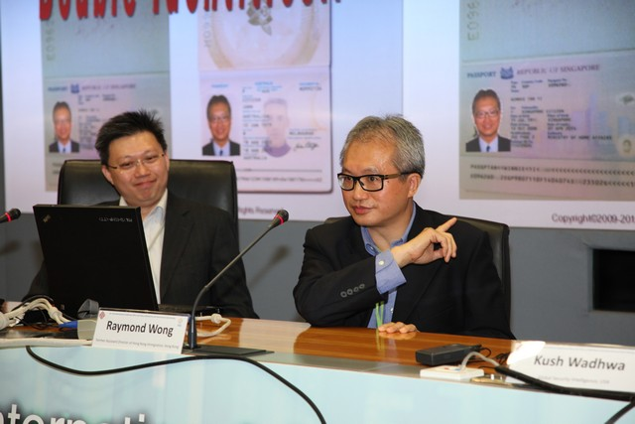 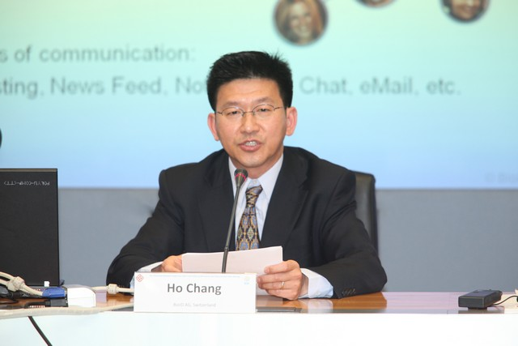

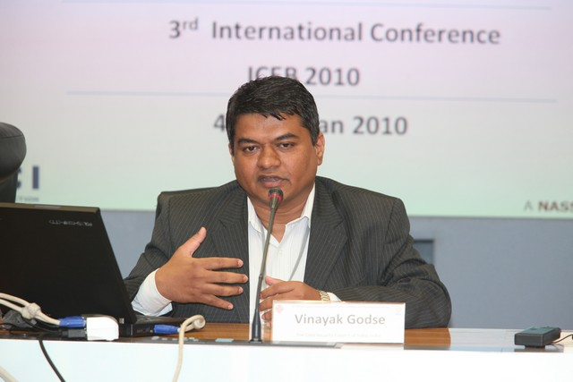 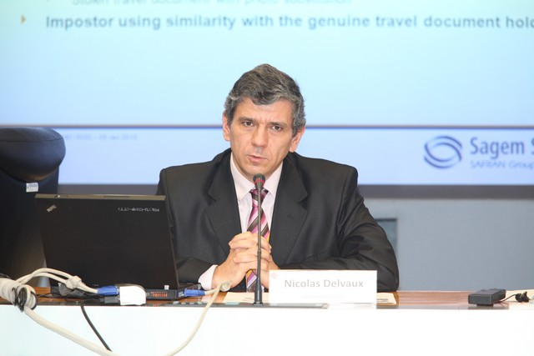

Upper left: Mr. Raymond Wong, from Jiaotong University, Shanghai, gives his keynote talk on *ABCD of BI*;   
Upper right: Ho Chang, from BioID AG, speaks on *Privacy and Data protection in Social Networks*;  
Lower left: Mr. Vinayak Godse, from Data Security Council of India, presents on the *Data Protection and Cyber Security*; Lower right: Mr. Nicolas Delvaux, from Sagem Sécurité, speaks on *Protected Biometrics for Identity Trust*.

The last or concluding session of this conference was chaired by Prof David Zhang and was intended to summarize the deliberations from this conference. The coordinator of RISE project, Prof. Emilio Mordini drew the conclusion that even though biometrics technologies may cause potential problems and risks, the use of this technology should not be restrained, and the solution for all the problems will be found by continuing dialogue and world-wide collaboration. This result underscores the importance that world-wide collaboration would play in the future usage of biometrics across the world. Dr. René von Schomberg from European Commission summarized that the public awareness should be raised on the biometrics technologies, to ensure more effective protection of personal privacy and biometrics data. Without adequate measures to protect the biometric profile of an individual, no widespread scheme to utilize biometric data would be successful, this necessitates further research into ensuring safety of biometric data and researchers must take this challenge with priority. Mr. John Kropf, from the Department of Homeland Security, USA, concluded that the challenges of using biometrics *versus* privacy intrusion and human rights violation are world-wide, and to address these issues authorities would need world-wide collaboration, dialogues among different communities and communications among various domains of expertise ranging from bureaucrats to research scientists.

The conference venue was also utilized to organize the RISE partner’s meeting in the post conference session after the lunch. This meeting was chaired by Prof Emilio Mordini, who reviewed the project progress and the work plan on the deliverables of the RISE project. The proceedings of this conference were published as post conference proceedings by Springer, Lecture Notes in Computer Science, LNCS 6005. The authors of each of the accepted papers were provided ten additional days following this conference so that they can submit the revised version of their papers that incorporates the comments and feedback received during the conference. The third international conference on ethics and policy of biometrics and international data sharing witnessed wide consensus on designating biometric data as sensitive. The conference debates also outlined the need to bring more public awareness for higher privacy and security controls in popular social networking websites. In summary this conference was highly successful in bringing the awareness on the ethics and policy of biometrics and a significant step forward in developing consensus, collaborations and understanding on ethical, medical, legal, social, cultural and political issues among researchers, policymakers, consumers and privacy groups which usually address these issues from different perspectives.